Colouring in Competition!

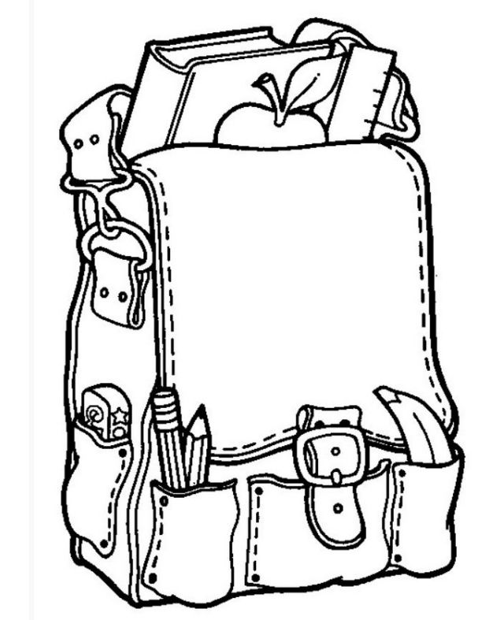
Name:____________________________ Age:____________ School:____________________________________

