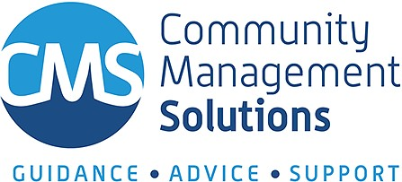

Full HR Service
We help put your mind at ease by taking care of all your HR needs to ensure that you are fully compliant, and that your staff are performing at their peak, allowing you to focus on matters that are your expertise.

"As a full HR Service, you are allocated with your own HR Consultant so that you receive consistent service, just like having your own HR employee, and have a whole team of HR specialists as backup.”

Industrial Relations
Help with interpreting Awards & Enterprise Agreements, dispute management, conflict resolutions, Redundancies, Disciplinary actions...

Performance Management
Bringing the best out of your team is one thing, but managing poor performance is another thing which must be done correctly with a view of benefiting all stakeholders. We can help you with this.
BOOK A CALL FOR MORE INFORMATION
07 3852 5177
info@cmsolutions.org.au
www.cmsolutions.org.au

Workplace Investigations
When situations go pear shaped and you need advice on the best practice and legislation requirements to conduct a workplace investigation, our IR team are here to assist.

Terminations & Redundancies
Unfair dismissal claims are time consuming and very costly. We help ensure that your approach and processes are in line with Fair Work requirements and humanly considerate, because people's livelihood matters.

WHS, WorkCover, RTW

Full HR Service
We help ensure that you pro-actively have systems and processes to minimise risks. If and when the need occurs, we help ensure that you meet your employer obligations.

Recruitment
We assist with finding the most suitable candidate for the role and for the organisation. This includes sourcing, on- boarding, and managing the candidate during the probation period. We guide you through this process from the get go.

Learning and Development
General staff training and Leadership development are key to cultivating a strong, engaged, and growing team. Customisation can be done at a fee.

Accreditation Audits & Reports
Internal HR Audits provides you with a clear picture of any gaps to your current processes, and it allows you to priorities your HR tasks, especially during Change Management.

HR Advice & Guidance Checklists & Templates

We provide you with advice that is specific to your individual circumstance, Achieving balance between legislation requirements, and caring for your valuable employees.

Calculation of Wages
We help you calculate the correct wage that is specific to the position classification, years of experience, and relevant experience, according to the relevant Award and Enterprise Agreement.

Supplementary services
Letter of Appointments, Position Descriptions, On-boarding documents, Departures, Change of Circumstances, Policies, Performance Appraisals...

Policies & Procedures
We help ensure that you have the compulsory policies in place, and assist with providing you with relevant advise on updating existing policies and procedures in line with current legislation and best management practice.

Book keeping Workforce Planning Strategic Planning Change Management
Book a call for more Information
07 3852 5177
info@cmsolutions.org.au
www.cmsolutions.org.au
Payroll
Enterprise Agreements

